

Schools must use the funding to make additional and sustainable improvements to the quality of PE and sport they offer. This means that you should use the Primary PE and Sport Premium to:

- develop or add to the PE and sport activities that your school already offers
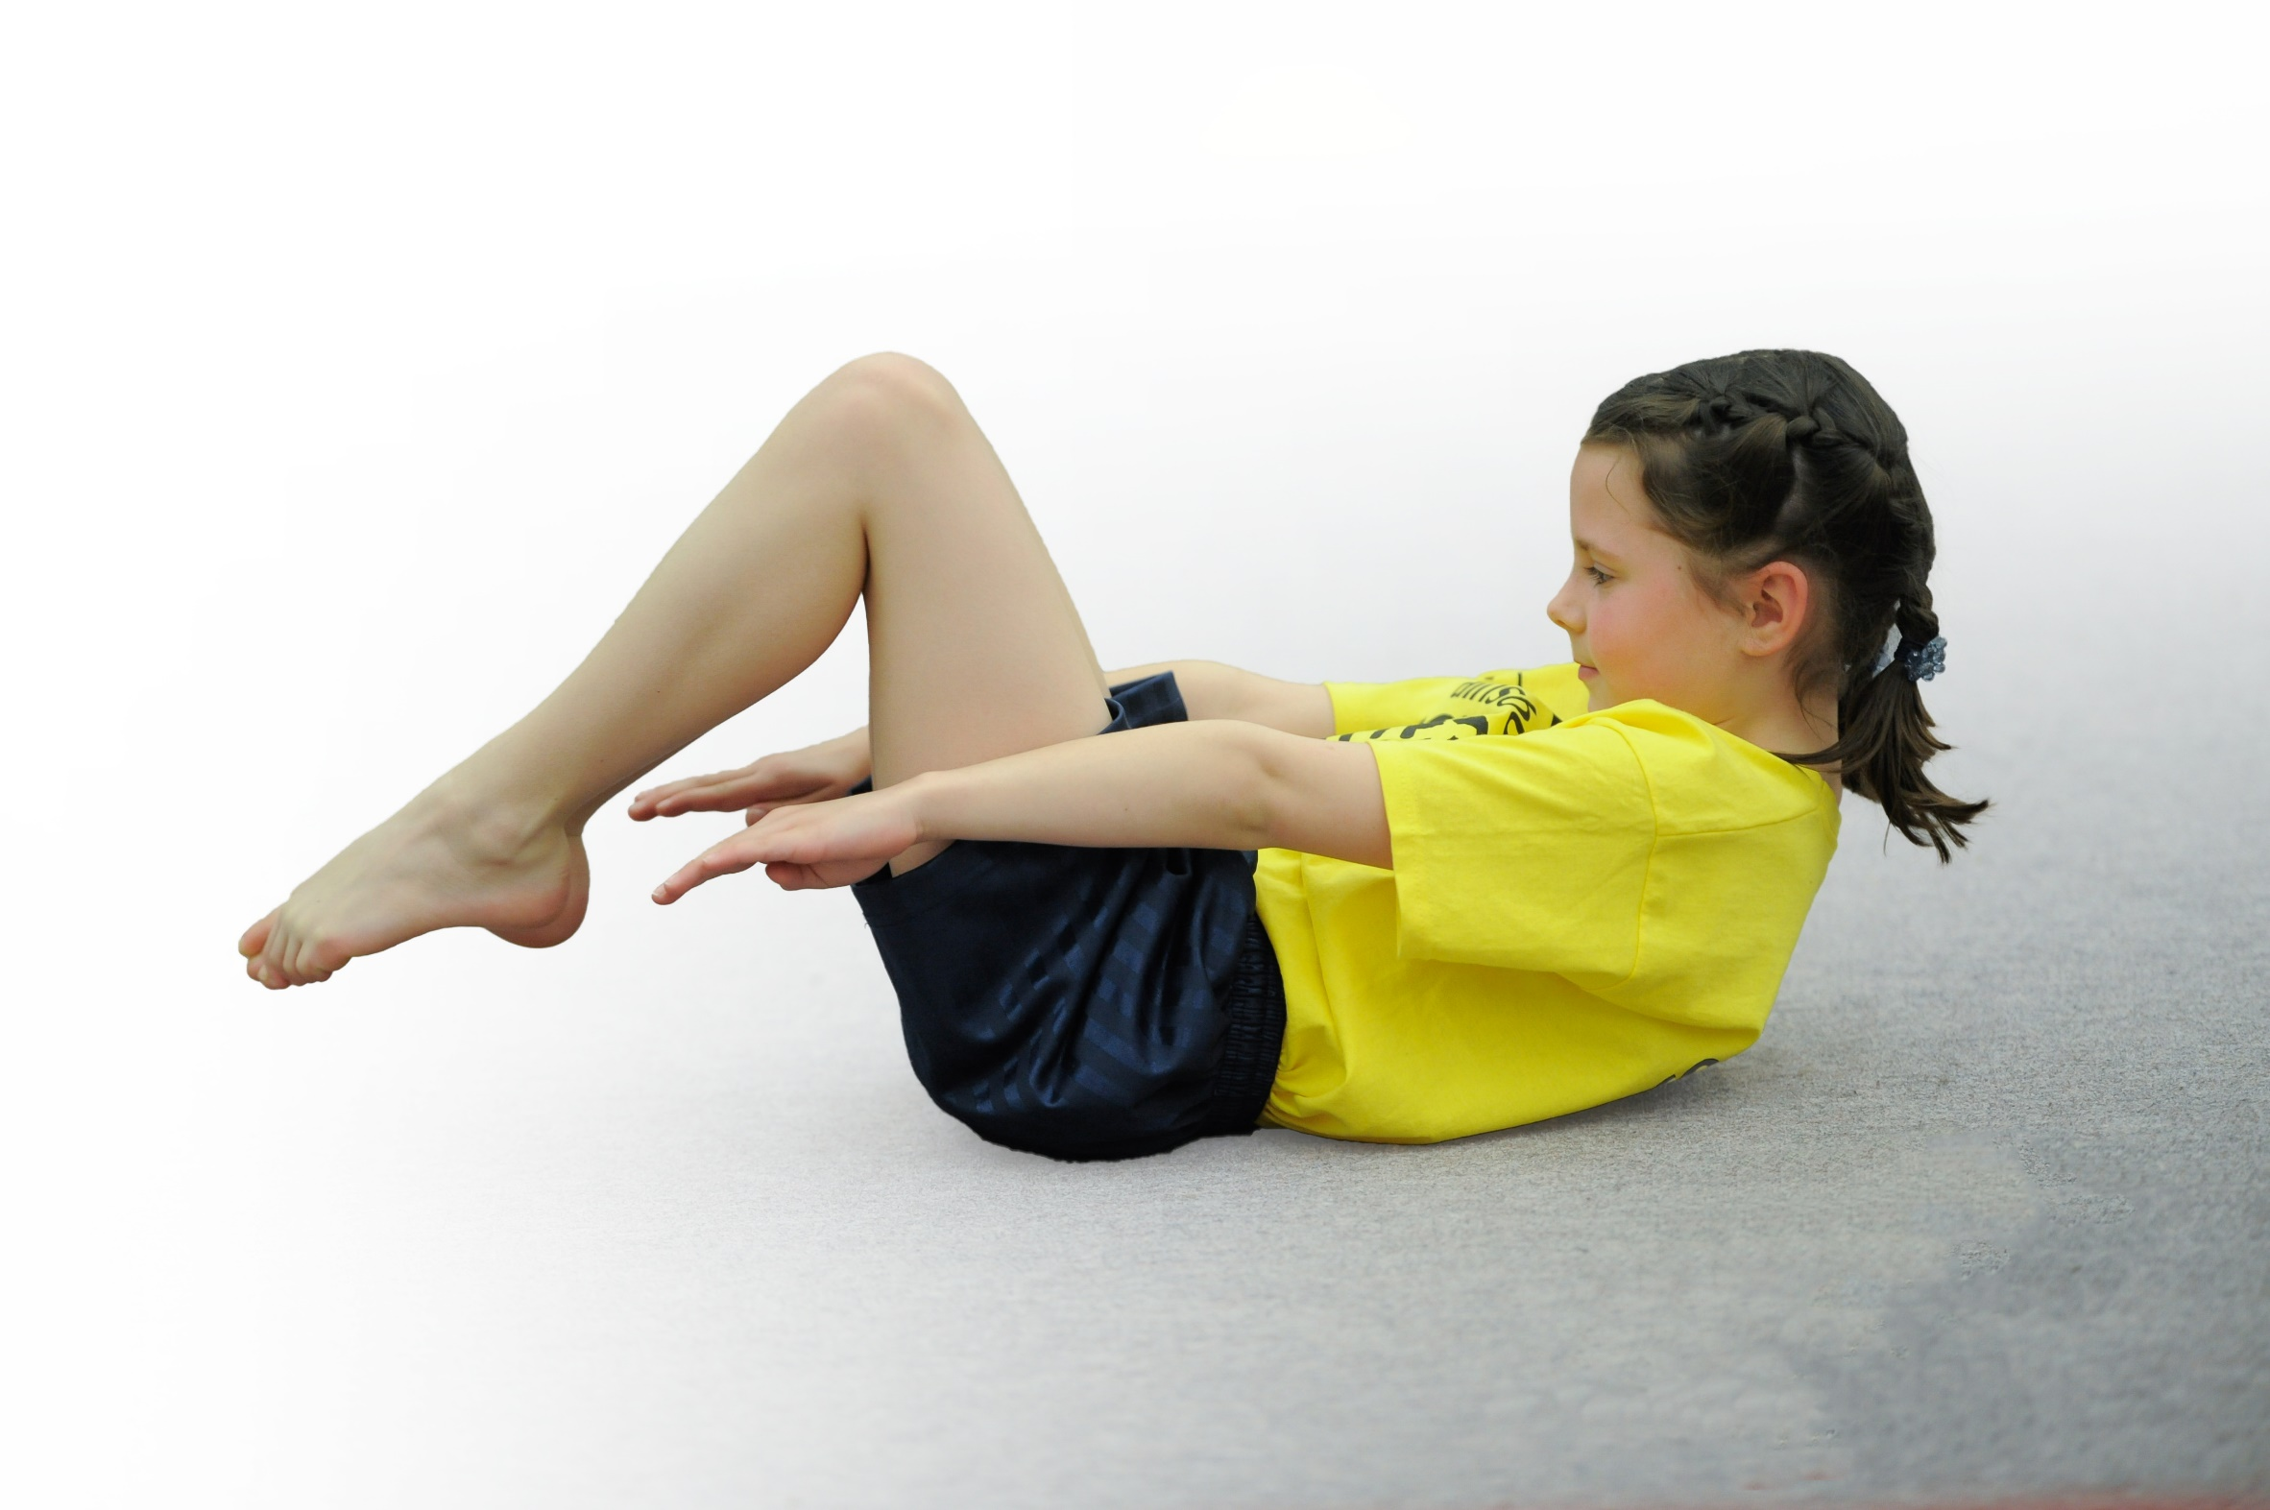
- build capacity and capability within the school to ensure that improvements made now will benefit pupils joining the school in future years

Please visit gov.uk for the revised DfE guidance including the 5 key indicators across which schools should demonstrate an improvement. This document will help you to review your provision and to report your spend. DfE encourages schools to use this template as an effective way of meeting the reporting requirements of the Primary PE and Sport Premium.

We recommend you start by reflecting on the impact of current provision and reviewing the previous spend.
Under the Ofsted Schools Inspection Framework, inspectors will assess how effectively leaders use
the Primary PE and Sport Premium and measure its impact on outcomes for pupils, and how effectively governors hold them to account
for this.

Schools are required to publish details of how they spend this funding as well as on the impact it has on pupils’ PE
and sport participation and attainment.
We recommend regularly updating the table and
publishing it on your website as evidence
of your ongoing review into how you are using the money
to secure maximum, sustainable impact. To see an example of how to complete the table please click HERE.

Support for review and reflection - considering the 5 key indicators from DfE, what development needs are a priority for your setting and your students now and why? Use the space below to reflect on previous spend, identify current need and priorities for the future.

Key achievements to date: | Areas for further improvement and baseline evidence of need:
- Purchased equipment to support teaching of Cambridgeshire Scheme of work for PE, ensuring that children can have the best possible experiences in learning the different skills.  - Introduced Active Math’s and 5 a day TV to support daily 30 mins of activity. Classes have access to both to help enhance learning and being active  - Organised Premier Education to run various afterschool and lunch time clubs.  - Balanceability and Bikeability schemes being run for reception and children in Year 3 & 4.  - Introduction of a broader range of sports being offered. We have run clubs throughout the year for dance, circus skills, cheerleading, badminton, netball, tag rugby, football, multi-sports, speed stacking, cooking, drama, gymnastics, dodgeball and forest schools.  - Creation of Sensory room to provide a space to support those children with SEN, as well as targeting key children that may struggle in class and need sensory/active breaks to support in their learning. (To be installed November 2019) | - Development of teaching staff in PE through support from Cambridgeshire School Sports Partnership. Member from the CSSP team to work with all teachers throughout the school year to support specific areas that teaching staff are less confident in delivering.  - Spread swimming out across the year groups, with KS2 having swimming sessions for a term each year.  - Continue to introduce a broader range of sports through lunchtime and after school clubs and provide information and links for possible clubs that children could join outside of school. Also promote healthy changes through a focus on ‘health and wellbeing’ delivered by Premier Education.  - Introduction of REAL PE and change of focus on how PE is taught throughout the school

Meeting national curriculum requirements for swimming and water safety | Please complete all of the below*:
What percentage of your current Year 6 cohort swim competently, confidently and proficiently over a distance of at least 25 metres? | %
What percentage of your current Year 6 cohort use a range of strokes effectively [for example, front crawl, backstroke and breaststroke]? | %
What percentage of your current Year 6 cohort perform safe self-rescue in different water-based situations? | %
Schools can choose to use the Primary PE and Sport Premium to provide additional provision for swimming but this must be for activity over and above the national curriculum requirements. Have you used it in this way? | Yes. In previous years swimming was undertaken during the Summer term in Year 1, and Autumn/Spring of Year 2. In order to target those that have not yet managed to achieve the standard required by the end of Year 6, top up swimming sessions were introduced to take part during the Summer term in Year 4, and Autumn/Spring of Year 5. This year swimming is being switched to cover Year 3-5 KS2 classes and if children are still in need of sessions after this, smaller top up groups will be provided for any Year 6 that require this.
*Schools may wish to provide this information in April, just before the publication deadline.

Action Plan and Budget Tracking
Capture your intended annual spend against the 5 key indicators. Clarify the success criteria and evidence of impact that you intend to measure to evaluate for students today and for the future.

Academic Year: 2019/20 | Total fund allocated: £23,941 (£6,681 carried forward from last year for Sensory Room Project. | Date Updated: 05.11.2019
Key indicator 1: The engagement of all pupils in regular physical activity – Chief Medical Officer guidelines recommend that primary school children undertake at least 30 minutes of physical activity a day in school |  |  |  | Percentage of total allocation:
 |  |  |  | 0.7%
School focus with clarity on intended impact on pupils: | Actions to achieve: | Funding allocated: | Evidence and impact: | Sustainability and suggested next steps:
- To bring active learning into the school in as many possible ways as possible. The school itself has a key focus on providing outdoor learning areas. This needs to be further supported through PE in as many areas as possible.  - Play Leader training for Year 5 children to run active games during lunch times on KS1 and KS2 playgrounds. | - Introduction of the Daily Mile.  - Active 30:30 Resource pack  - Deliver staff training on these resources.  - CSSP support in training Play Leaders from Year 5. Children to help deliver guided active games for children during lunchtimes. | - No cost  - £160 | - To be evidenced through observations after staff training has been undertaken.  - Lunchtimes to have activities available on a daily basis for KS1 and KS2 run by the Play Leaders. | - Overall, long term impact should be seen through observations of classes and discussions with children.  - Continue with Play Leader training into the following year so that more activities can be run across the school during lunchtimes. Both Year 5 and 6 to have Play Leaders in school year 2020-2021.
Key indicator 2: The profile of PE and sport being raised across the school as a tool for whole school improvement |  |  |  | Percentage of total allocation:
 |  |  |  | 37.2%
School focus with clarity on intended impact on pupils: | Actions to achieve: | Funding allocated: | Evidence and impact: | Sustainability and suggested next steps:
- To create a sensory room to support children with SEN and provide an area for targeted children to access in order to improve whole school participation in ALL areas of the curriculum. This area will support children in refining their fine and gross motor skills as well as provide an area for children to have active breaks that will support in their overall learning.  - To ensure that correct equipment and resources are available for the successful teaching of all areas of the PE curriculum.  - To provide opportunities for the school to raise money through sponsored sporting events. | - Working with the SLT to design and construct a suitable sensory room that benefits the children in school as well as providing a space that will have a sustained impact for years to come. The area will be set up with activity cards that the adult working with the child accessing the room will select and support during the session.  - Stock take equipment on a termly basis. Purchase new supplies when and if needed. Replace and increase storage units for sports equipment on All-weather pitch and Playground for Play Leader equipment. Equipment for Sensory circuits provision.  - Kick Challenge provided by Premier Education. Children to raise money for the school to be put towards increasing activity throughout the school. Premier Education to come in for a day and run the event. | - £5,840 (To be taken from funding committed from previous year’s budget).  - £3076  - No cost | - To be evidenced upon completion of room.  - Having own equipment to run the course when best suits the needs of the class. Equipment readily available to staff on All-weather pitch.  - Funding Assembly run by Premier Education, awarding prizes to children for fastest kick and most money raised. Money raised to be used to raise profile of sports, buying in varied sports days. | - Upon completion of the room, discussion with key staff (SLT and TAs) to create activity cards based around the different sensory areas of the room, thinking about the needs of the children that will be accessing the room.  - We are now able to run Balanceability in reception on our own. Stock for PE games will be up to date and relevant to the learning.  - Look into success of sponsored event and look into options of continuing this on a yearly basis. Link to Daily Mile and have sponsored targets. E.G. Sponsor classes to walk from England to South Africa.

Key indicator 3: Increased confidence, knowledge and skills of all staff in teaching PE and sport |  |  |  | Percentage of total allocation:
 |  |  |  | 7.20%
School focus with clarity on intended  impact on pupils: | Actions to achieve: | Funding  allocated: | Evidence and impact: | Sustainability and suggested  next steps:
- Improved quality of children’s physical education throughout the school to ensure they are competent and confident.  - Chance to Shine Cricket to support teachers in teaching of Kwik Cricket.  - To provide directed coaching sessions for staff.  - Teacher to have training in REAL PE to help raise the profile of PE in school and among children that are less likely to participate in PE. | - CSSP support for the school year. PE Coordinator to have access to CSSP for support in planning for PE sessions and to feed back to staff in any areas concerned. Coaches to come in to work with staff and up-skill teaching.  - Teaching staff to support Chance to Shine coaches and learn from coach  - Course to be run by CSSP for another year so that staff will be confident in teaching sports independently in subsequent years.  - real PE is a unique, child-centred approach that transforms how we teach PE to engage and challenge EVERY child. It has been developed to inspire teachers to enjoy teaching PE and transforms their confidence to deliver outstanding lessons. | - £900  - No Cost  - £460  - £365 | - To be evidenced through discussions with CSSP specialist teachers and Chance to Shine coaches.  - Observations of staff  - Discussions with teaching staff about confidence of taking this on themselves the following year.  - REAL PE is fully aligned to the National Curriculum and Ofsted requirements and focuses on the development of agility, balance, coordination, healthy competition and cooperative learning. | - Discuss with teachers which areas of the PE curriculum they would like support with.  - Observe teachers over the course of the year.  - Provide Chance to Shine support for new teachers to the school.  - Teaching staff to teach PE with confidence and greater knowledge.  - REAL PE to be rolled out to all classes and run alongside Cambridge scheme of work.
Key indicator 4: Broader experience of a range of sports and activities offered to all pupils |  |  |  | Percentage of total allocation:
 |  |  |  | 50.7%
School focus with clarity on intended  impact on pupils: | Actions to achieve: | Funding  allocated: | Evidence and impact: | Sustainability and suggested  next steps:
Additional achievements:  - To continue to provide a variety of sports clubs for children to attend during lunch time or after school.  - To engage children in creative arts and health and wellbeing.  - To experience a range of sports and activities outside of the normal sports on offer | - Continue to build links with clubs in the area to provide a varied and enjoyable sports clubs.  - Premier Education to provide sessions, linking to core curriculum areas of Maths, English, Science, D&T and PSHE.  - Team Rubicon Skateboard and Scooter Day  - Limitless Games Day | - £5320  - £6270  - £250  - £300 | - Check on numbers of children attending various clubs. Seek to change clubs that are obtaining low attendance.  - Children are able to understand the importance of health and wellbeing. Taking part in active based learning opportunities outside of PE sessions.  - Children to have the experience of a range of sports not generally offered and to have exposure to a variety of sports. Possibility of starting After School clubs based around these sports. | - Children to join clubs outside of school, coaches of afterschool clubs identify and make recommendations for potential clubs they can join.  - Children to gain confidence in performing in front of audiences, understand the importance of health and wellbeing.  - Children to have confidence in experiencing a range of sports and to encourage being active in a variety of ways.
Key indicator 5: Increased participation in competitive sport |  |  |  | Percentage of total allocation:
 |  |  |  | 4.2%
School focus with clarity on intended  impact on pupils: | Actions to achieve: | Funding  allocated: | Evidence and impact: | Sustainability and suggested  next steps:
To participate in intra and inter schools sports competitions. | - Plan curriculum to fit in with the CSSP competitions schedule.  - Ensure staff are aware and teaching ‘Mini Festivals’ from Cambridgeshire PE curriculum.  - Transportation to sports events if required.  - Links with NCA and take part in festivals hosted by them. | - £1000 | - To be evidenced upon participation of intra and inter school competitions. | - Discussions with teaching staff about upcoming competitions.  - Teaching staff to highlight potential children to participate on inter school events

